|  |  |  |
| --- | --- | --- |
|  | DISPLAY A STRING |  |
| Exp No.: 10 |  | **Name:** S Vishakan |
| Date: 14-10-2020 |  | **Reg. No:** 18 5001 196 |

**AIM:**

To write an assembly language program to display a string through the standard output.

**PROGRAM – 1: DISPLAY A STRING:**

**ALGORITHM:**

1. Begin.
2. Declare the data segment.
3. Initialize data segment with a variable for a string “Hello World!”
4. Close the data segment.
5. Declare the code segment.
6. Set a preferred offset (preferably 100h)
7. Load the data segment content into AX register.
8. Load 09h into AH register (DOS function to write to standard output)
9. Store the offset of the string in DX register.
10. Introduce an interrupt for safe exit. (INT 21h)
11. Close the code segment.
12. End.

|  |  |
| --- | --- |
| **PROGRAM** | **COMMENTS** |
| assume cs:code, ds:data | Declare code and data segment. |
|  |  |
| data segment | Initialize data segment with values. |
| message db “Hello World!$” | Variable message has “Hello World!” as a string. |
| data ends |  |
|  |  |
| code segment | Start the code segment. |
| org 0100h | Initialize an offset address. |
| start: mov ax, data | Transfer data from “data” to AX. |
| mov ds, ax | Move contents of AX to DS. |
| mov ah, 9 | AH = 09h for DOS function to write to STDOUT. |
| mov dx, offset message | Load offset address of message to DX. |
| mov ah, 4ch |  |
| int 21h | Interrupt the process with return code and exit. |
| code ends |  |
| end start |  |

**UNASSEMBLED CODE:**

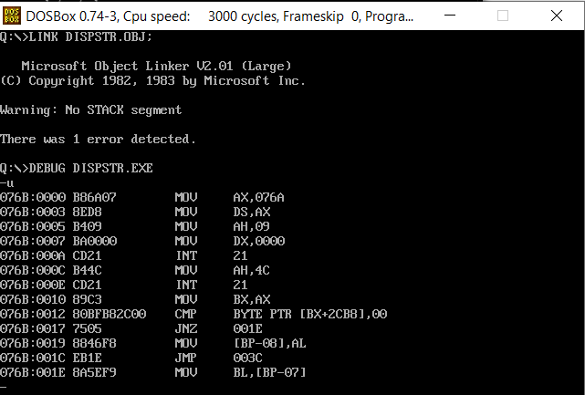

**SAMPLE I/O SNAPSHOT:**

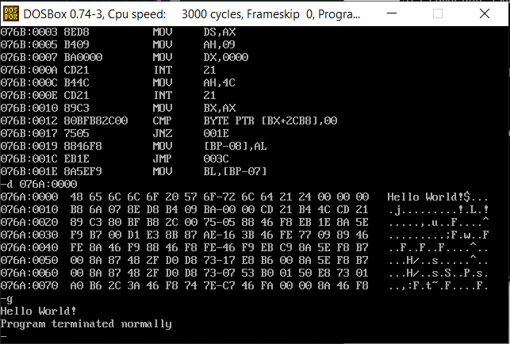

**RESULT:**

The assembly level program was written to display a string and the output was verified.